**Assignment -1**

Data Analytics

|  |  |
| --- | --- |
| Assignment Date | 27 September 2022 |
| Student Name | Ms. N.Ashifa |
| Student Roll Number | 19ITA05 |
| Maximum Marks | 2 Marks |

**Question-1:**

R&D spending: The amount which startups are spending on Research and development.

|  |
| --- |
| **Solution:** |

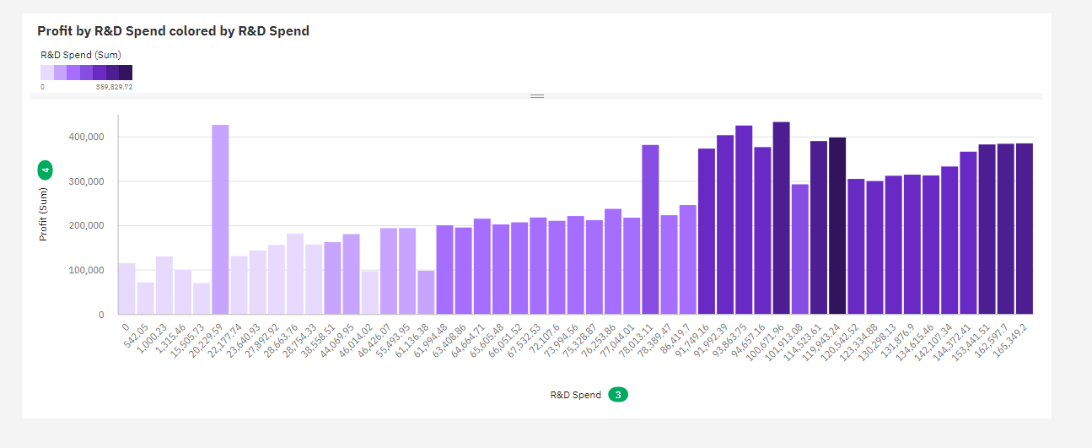

**Question-2:**

Administration spending: The amount which startups are spending on the Admin panel.

|  |
| --- |
| **Solution:** |

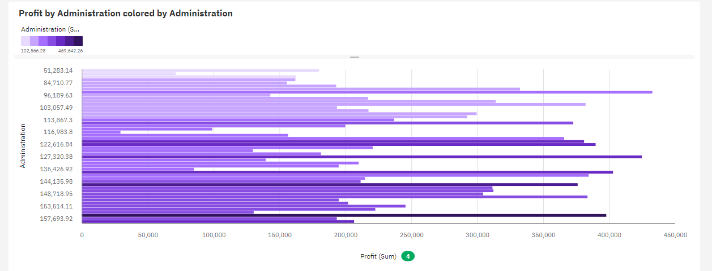

**Question-3:**

Marketing spending: The amount which startups are spending on marketing strategies.

|  |
| --- |
| **Solution:** |
|  |

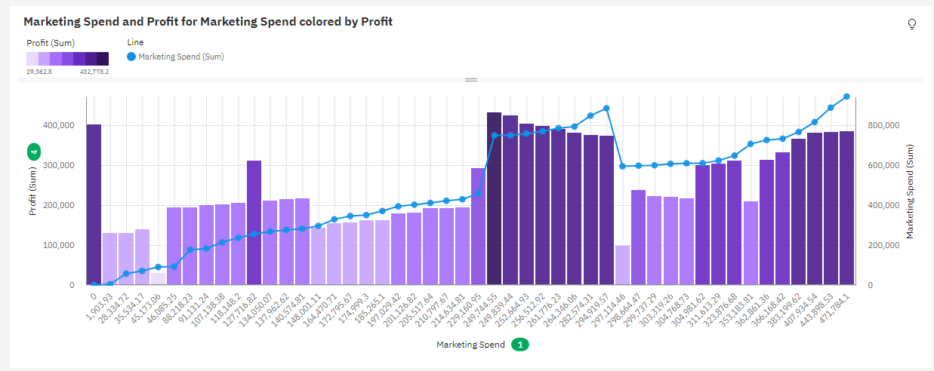

**Question-4:**

State: To which state that particular startup belongs.

|  |
| --- |
| **Solution:** |



  
  
  